**Task 5:**

Program 1:

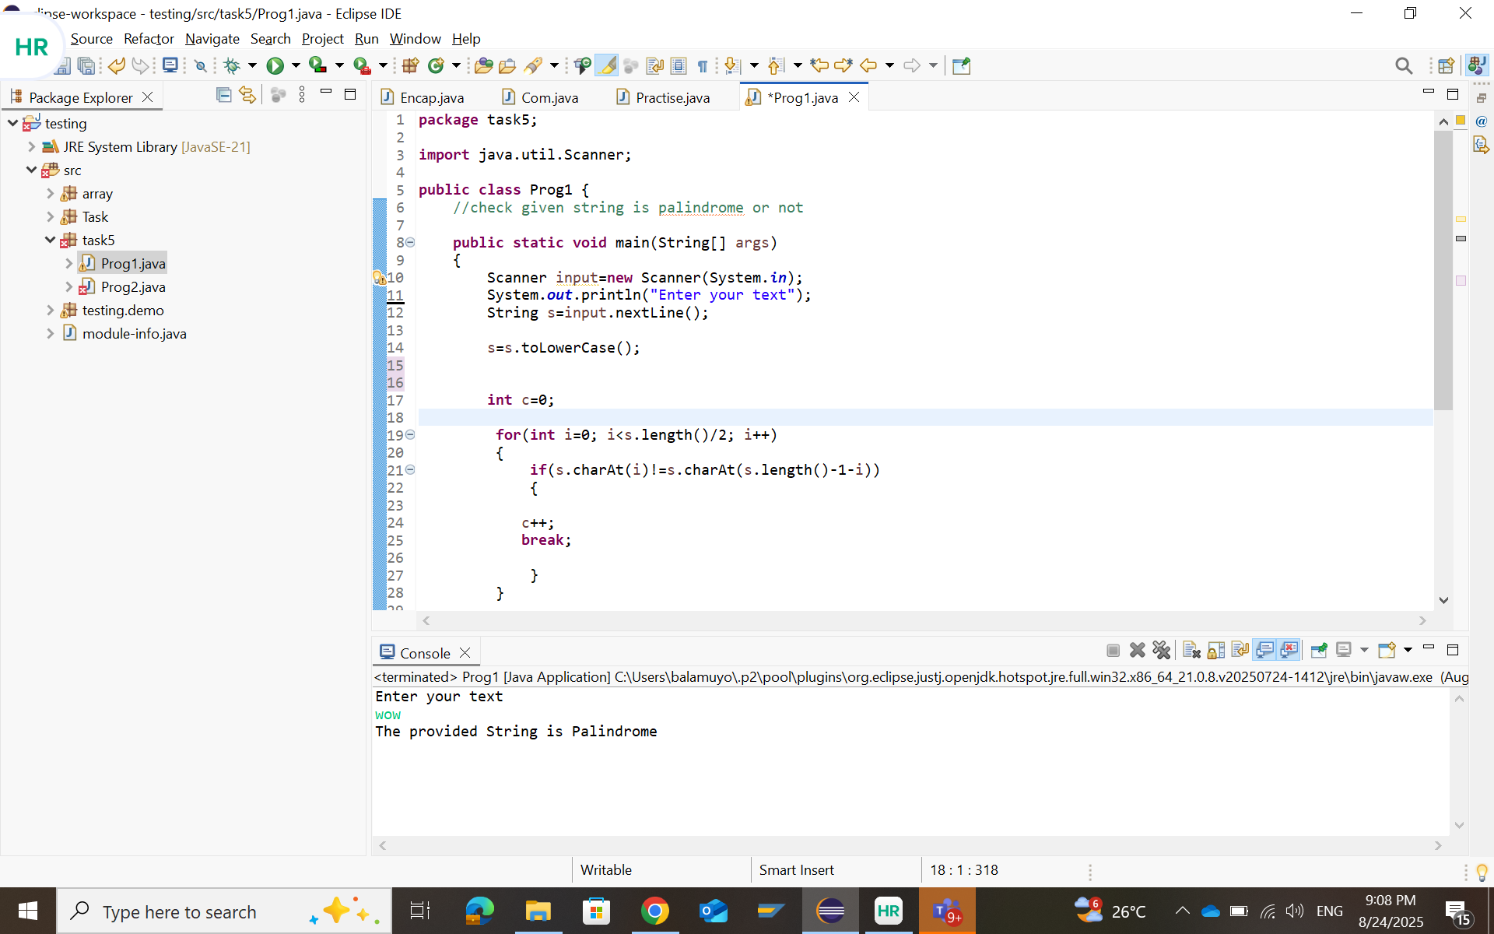

Program 2:

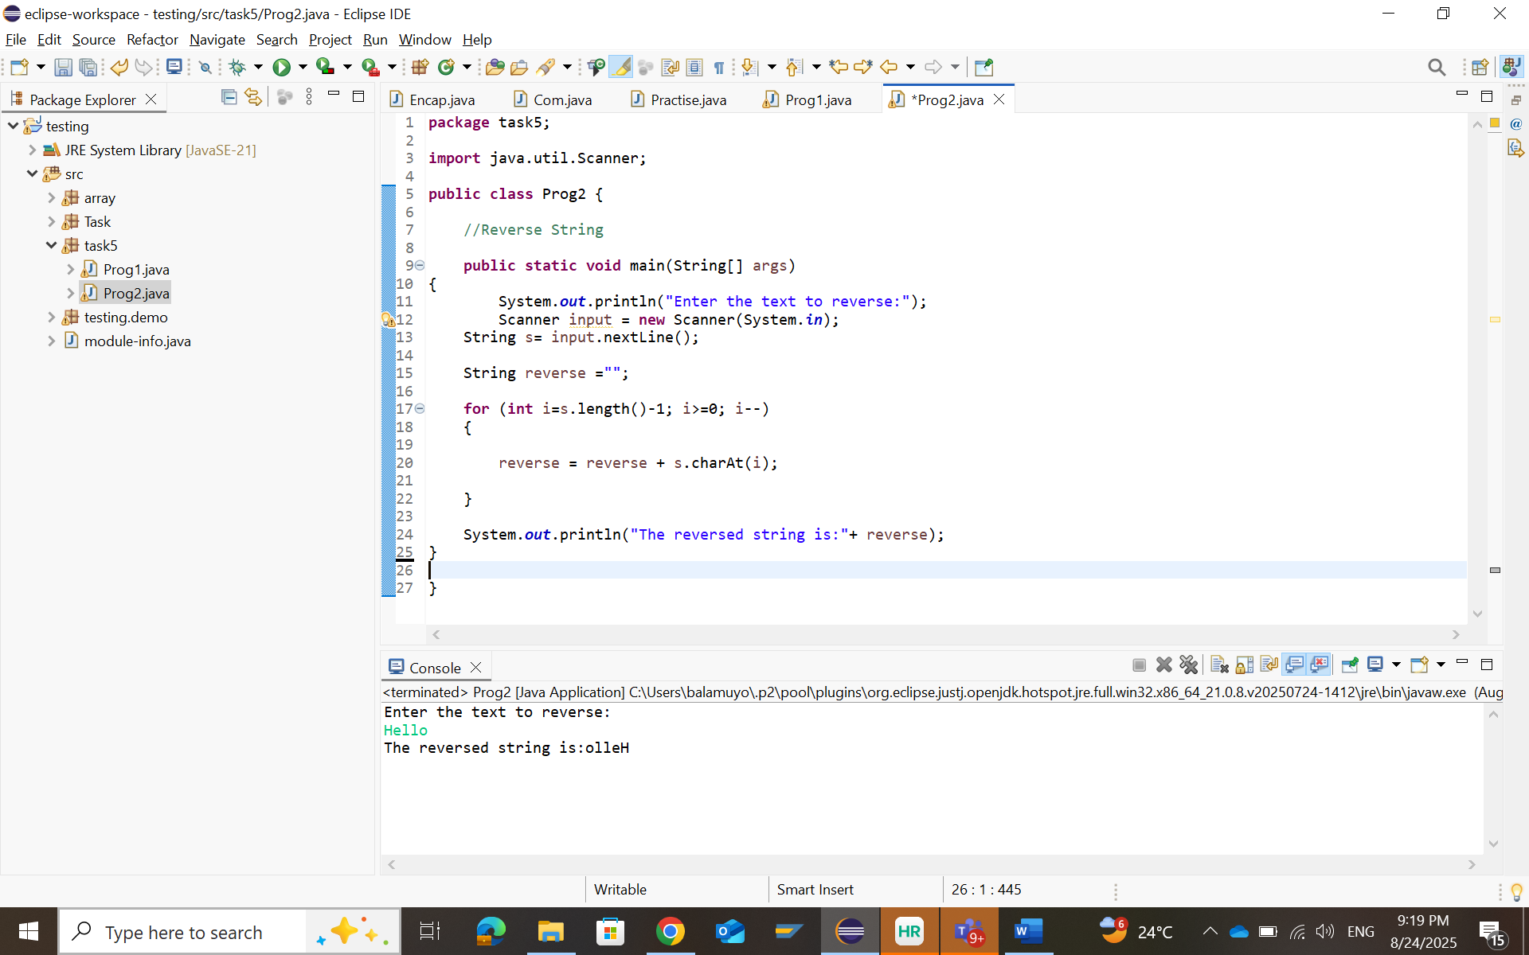

Program 3:

Program 4:

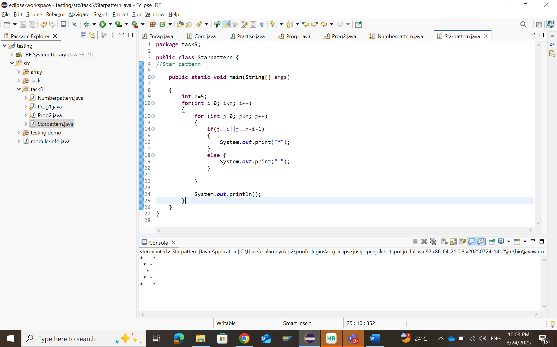

Program 5:

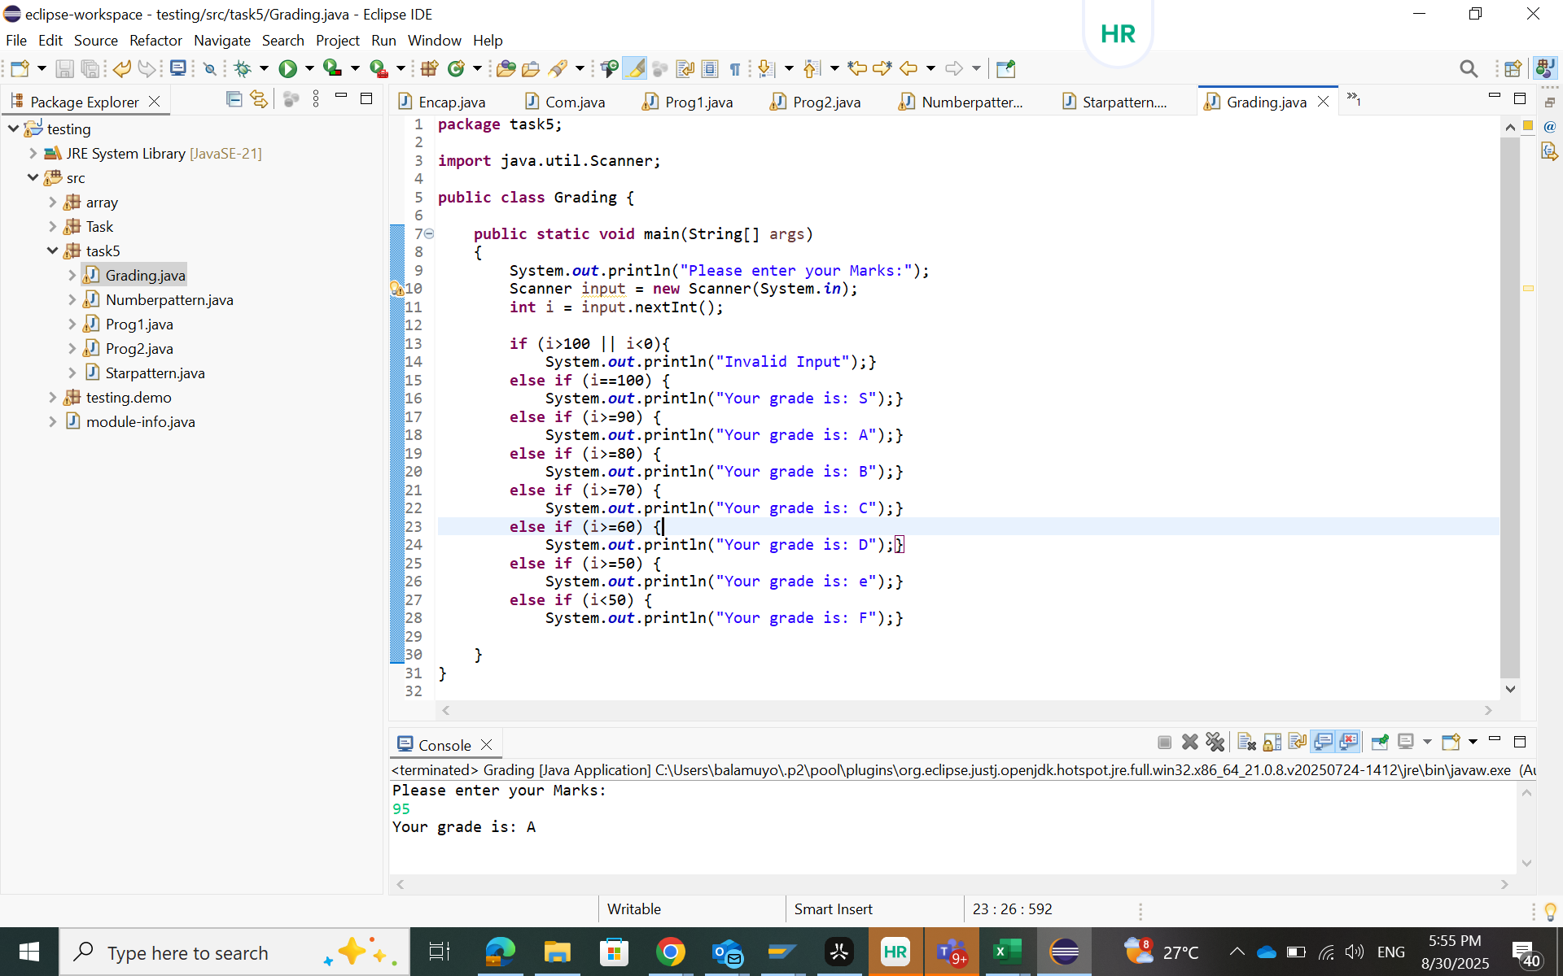

Program 6:

Program 7:

